Supabase Guide
1. What is Supabase?
Supabase is the tool we use to store and manage data from our onboarding form. Think of it like a smart spreadsheet in the cloud. Every time someone fills in the form, their info lands here automatically.
- You can view, search, filter, and export that data all from one place.
- You don't need any coding knowledge to use it (the dashboard is completely visual).
- Uses RLS policies (security measures) to ensure no one unauthorised can access the data

One thing to remember long term:
Supabase free plan pauses projects that haven't had any activity for 7 days. So if nobody submits the form for a week, it might pause. If that happens just log into Supabase and click "Restore project" to continue storing data, takes 2 minutes and nothing that was previously stored is lost.
If we want we can avoid this by upgrading to a paid plan later when the business is using the form regularly, it's about $25/month.
2. Creating Your Account
You've been added to the project already. All you need to do is accept the invitation:
- Check your inbox for an email from noreply@supabase.io
- Click "Accept invitation" in that email
- Create an account using your work email address
- Verify your email: Supabase will send you a confirmation link
- Done! You'll land directly in the project
To sign in on future visits: go to supabase.com → Sign In → enter your email and password.
3. Finding the Onboarding Data
Once you're in the project, here's how to get to the data:
- Go to projects open k2-onboarding
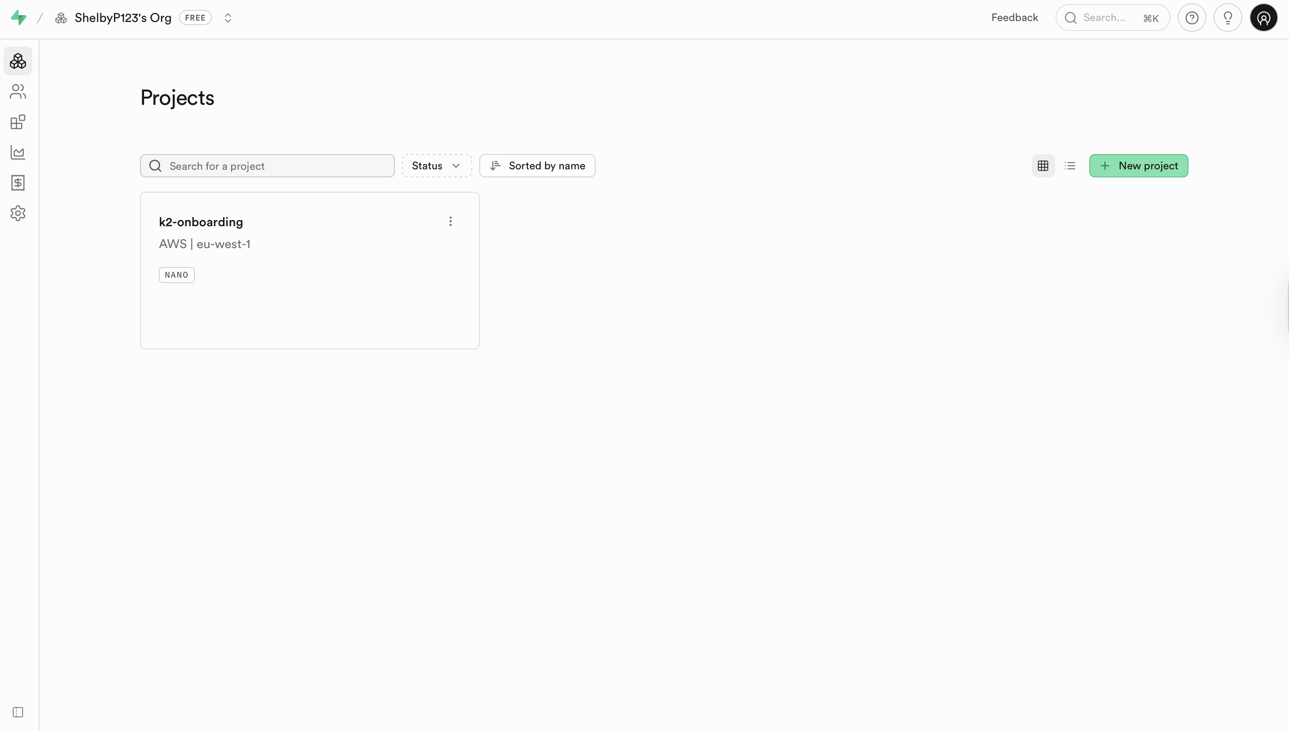

- Click Table Editor in the left sidebar
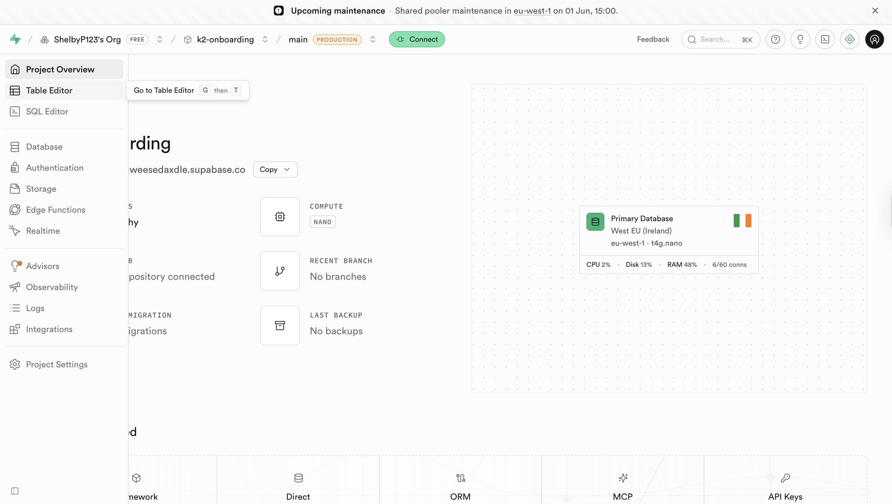

- You'll see a list of tables click on onboarding_submissions
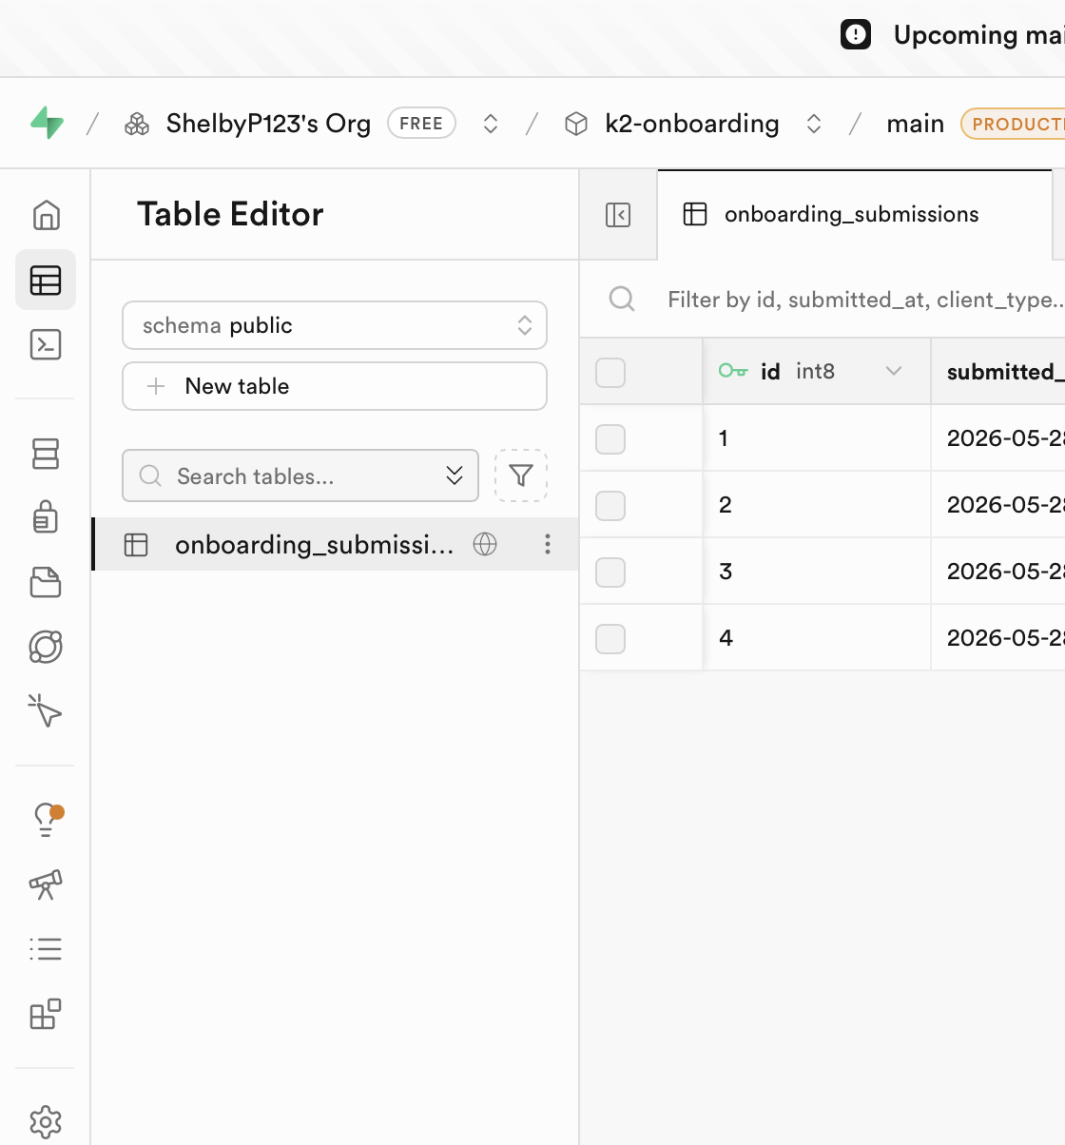

- All form submissions will load as rows, with each field as a column
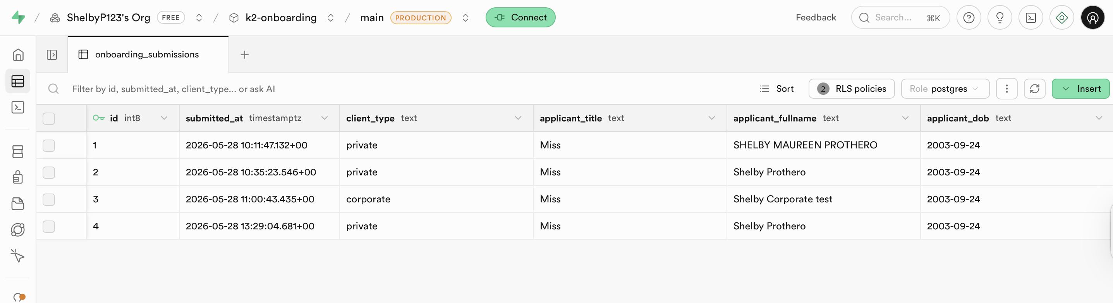

4. Sorting the data
Using the sort button (no coding needed)
- In the Table Editor, click sort → pick column to sort by
- Pick a column (e.g. submitted_at)
- Click Apply sorting
- Click anywhere on the screen (do not click x on top of box as that deletes the sorting rules)
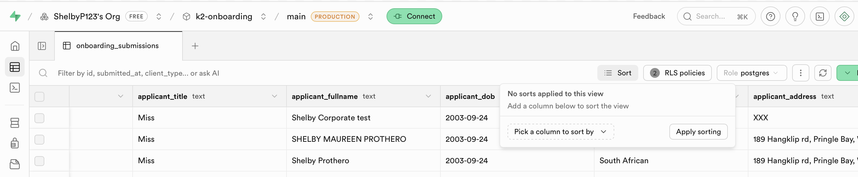

5. Finding Specific Rows
Using the Filter button (no coding needed)
- In the Table Editor, click Filter → Add filter
- Pick a column (e.g. email)
- Choose a condition (e.g. equals or contains)
- Type your value and hit Apply
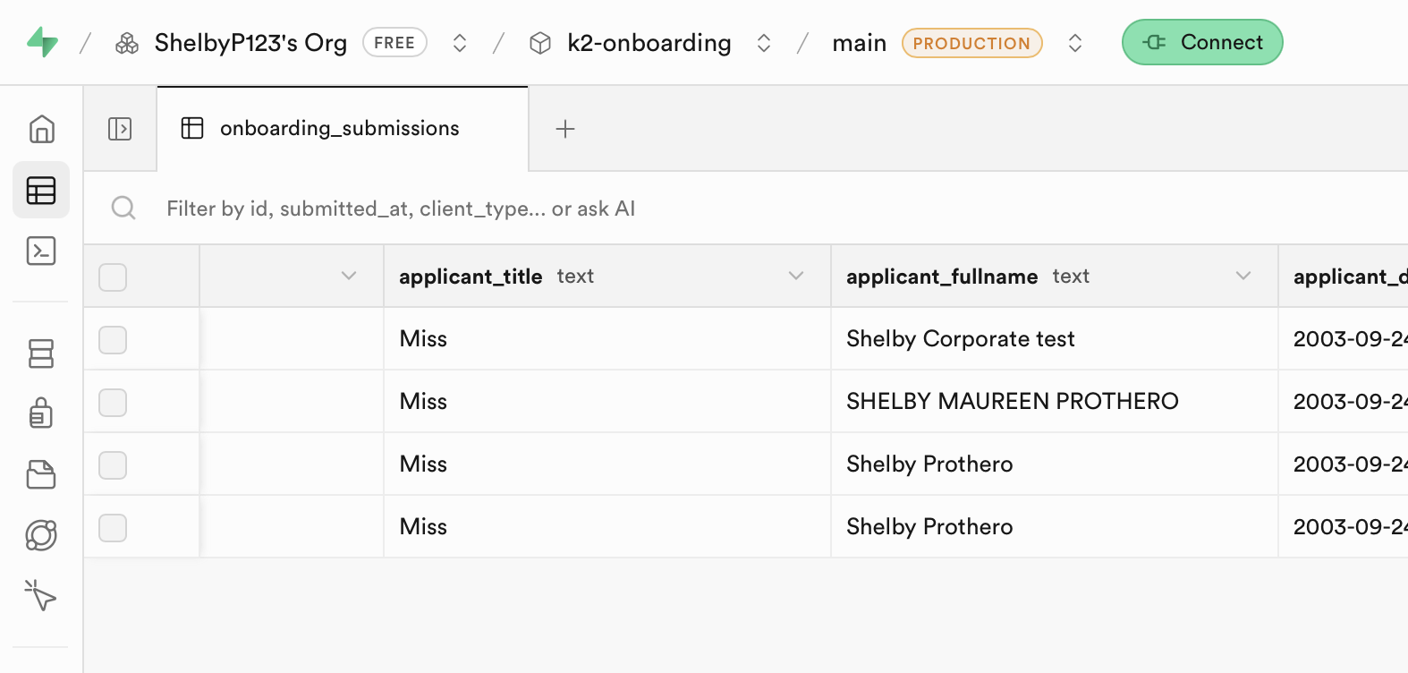

6. Accessing Uploaded Files
Any files uploaded through the onboarding form are stored in Supabase's Storage section (not the database).
Here's how to find them:
- Click Storage in the left sidebar
- You'll see a list of buckets, these are basically folders. Look for the one named documents
- Click into the bucket to browse the files
- Click any file to preview it or use the Download button to save it to your computer
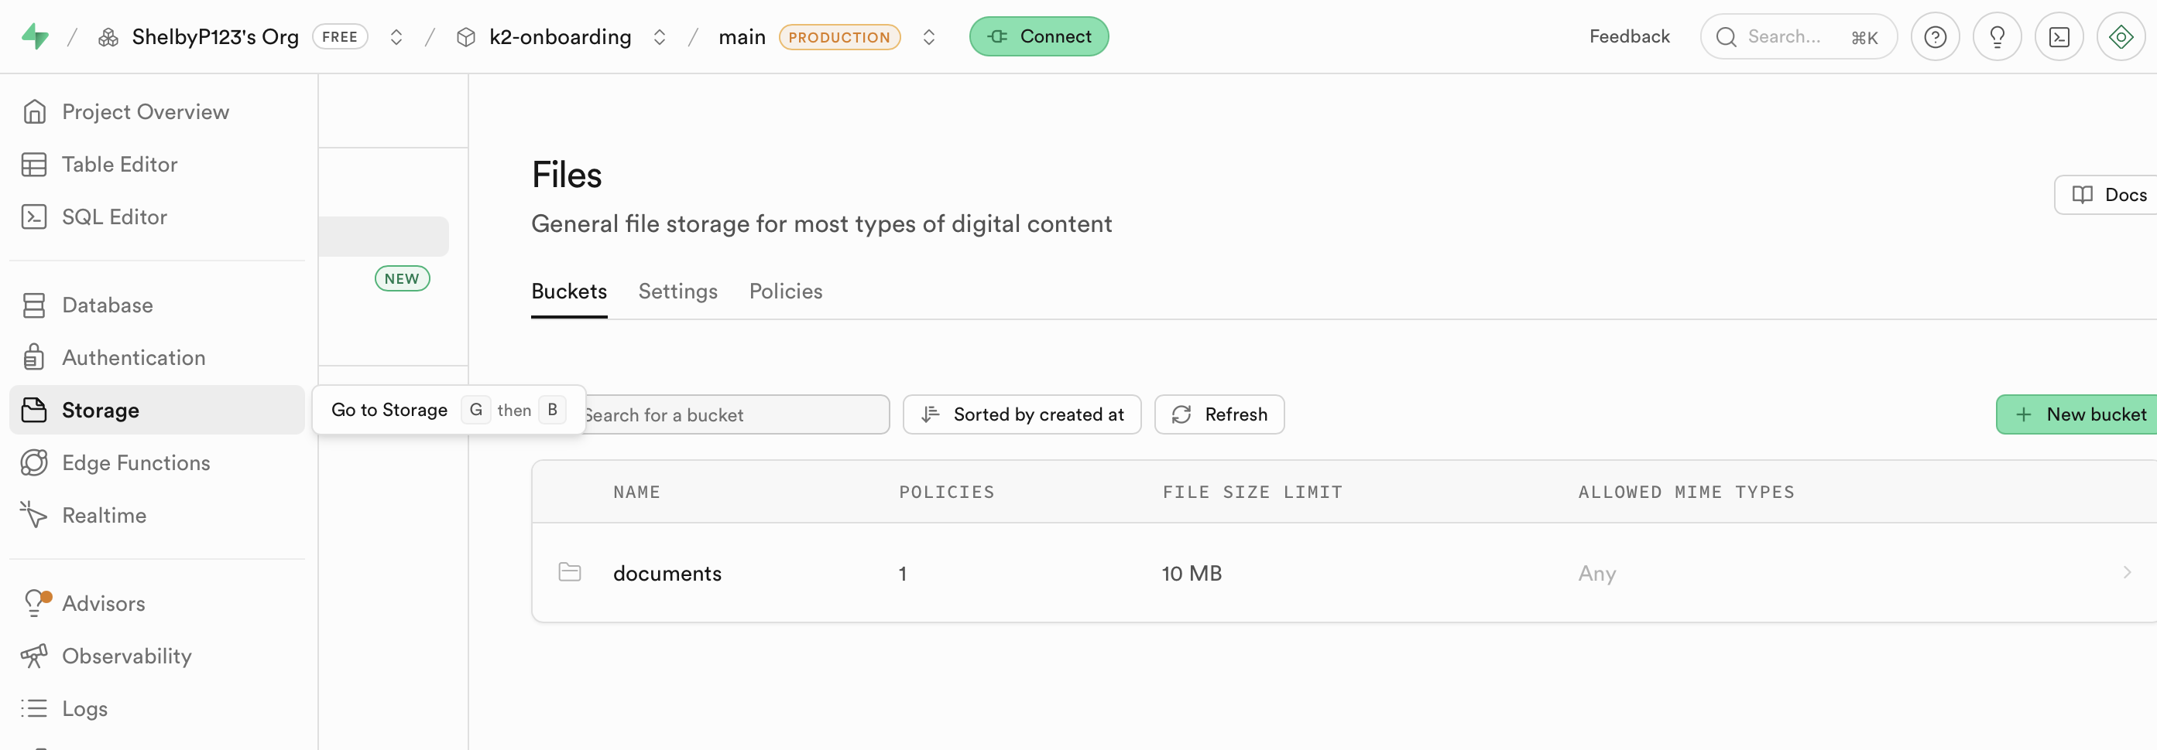

A few things to know:
Files are usually organised by submission, look for folder names that match a user's ID or email, otherwise the corresponding label at the end of the submission row (found in the table editor tab).
7. Exporting Data
Export the full table
- Open the table in Table Editor
- Click the 3 dots next to onboarding_submissions
- Click Export data Export table as CSV
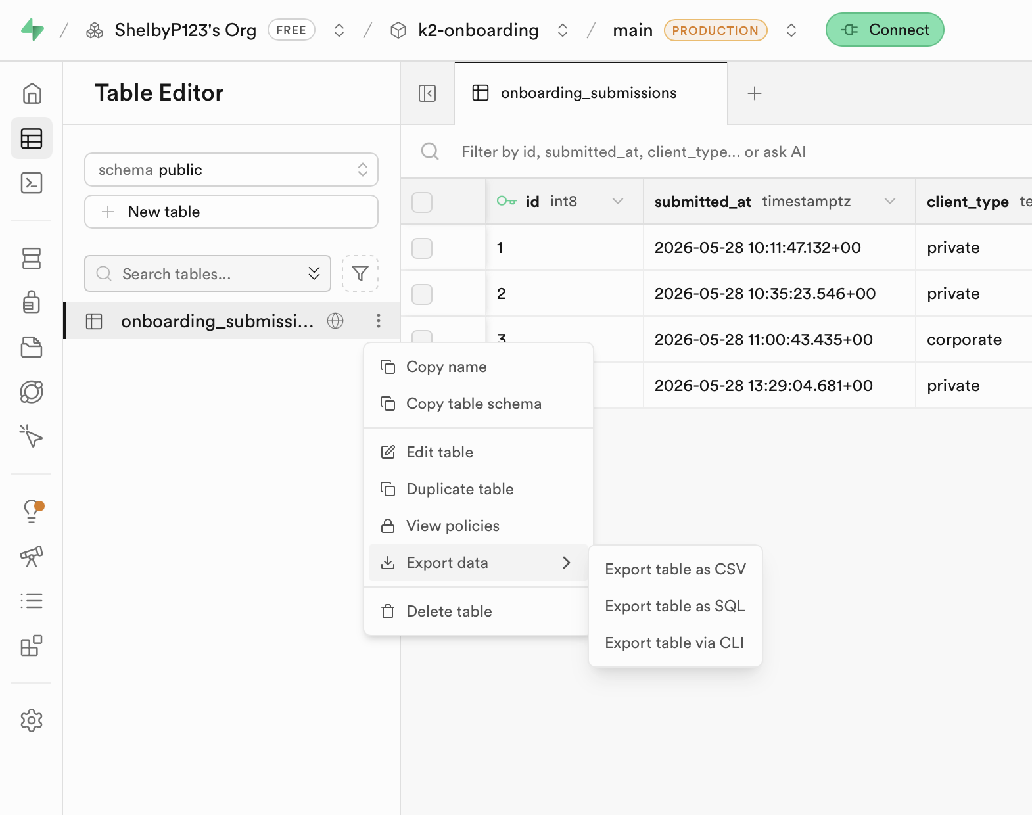

- The file downloads to your computer, open it in Excel or Google Sheets

Export the full table
- Select the rows you want to export
- Click Export data Export table as CSV
